**TUTORIAL**

**Provisioning IBM Cloud Resources**

**Using the IBM Cloud Provider for Terraform**

# 

**Table of Contents**

Introduction 3

Step 1: Welcome to Terraform 5

Step 2: Introduction to the IBM Cloud Provider 6

Step 3: Set up your environment 7

Step 4: Run Terraform Container 8

Step 5: Get familiar with the architecture 10

Step 6: Review Terraform files 13

Step 8: Deploy to IBM Cloud 17

Introduction

In this tutorial, you will move through a brief introduction to Terraform, explore and apply IBM Cloud Terraform Provider, and use a Docker container to deploy an IaaS architecture to IBM cloud. Since the content is maintained in publicly in GitHub, you and your team can then extend their experience to continue deployments after the lab.

**Prerequisites:**

1. You must have an IBM Cloud account that can deploy infrastructure resources. The account is free and provides access to everything you need to develop, track, plan and deploy apps. [Sign up for a trial](https://console.bluemix.net/registration/?cm_mmc=IBMBluemixGarageMethod-_-MethodSite-_-10-19-15::12-31-18-_-bm_reg). The account requires an IBMid. If you don't have an IBMid, you can create one when you register.
2. You need an infrastructure-as-a service (i.e. IaaS) API key and user name for the IBMid.
   1. To obtain these values in IBM Cloud, navigate to **Infrastructure** > **Account** > **User List** and find your user. Under the column **API KEY**, click the **View** link and you will find your IaaS API key and username.



1. You need existing and deployed Private and Public VLANs. You VLAN IDs are required for the deployment process.
   1. For instruction to request VLAN deployment, see [Getting started with VLANs](https://console.bluemix.net/docs/infrastructure/vlans/getting-started.html#getting-started-with-vlans).
   2. You can get the VLAN ID in one of two ways:
      1. Use the API or CLI command
      2. In IBM Cloud, click **Infrastructure** > **Network** > **IP Management** > **VLANs**, and then get the VLAN number from the URL.
   3. You need a desktop or operating system to run a Docker container. The setup instructions are included in this tutorial.

# Step 1: Welcome to Terraform

Before you apply Terraform to technologies with IBM services, it's important to understand how Terraform can be used. To ensure that you understand the examples in this tutorial and know how to extend them for your own use, review these resources:

* [“Terraform, Up and Running”](https://www.terraformupandrunning.com/)  By Yevgeniy Brikman
* [Terraform Google Group](https://groups.google.com/forum/#!forum/terraform-tool)
* [HashiCorp's Terraform Website](https://www.terraform.io/)
* [HashiCorp's Terraform Provider GitHub](https://github.com/hashicorp/terraform)

# Step 2: Introduction to the IBM Cloud Provider

Now that you're familiar with Terraform, get to know IBM Cloud Provider for Terraform by reviewing its related documentation, white papers, and repositories. You use this reference material in later tasks.

* [IBM Cloud Terraform Provider v0.12.0 Documentation](https://ibm-cloud.github.io/tf-ibm-docs/v0.12.0/)  
  This page contains the documentation on the latest version of the IBM cloud provider plugin. It contains descriptions for data, resources and variables used with the provider.
* [IBM Cloud Provider GitHub](https://github.com/IBM-Bluemix/tf-ibm-docs)  
  This repo contains the latest IBM cloud provider code you can use with the terraform run time to deploy resources in IBM cloud.
* [IBM Cloud Provider Dockerfile on Docker Hub](https://hub.docker.com/r/ibmterraform/terraform-provider-ibm-docker/)  
  This Docker file is used to build the image with terraform core version 0.11.0 and terraform IBM Cloud provider version 0.12.0.
* [IBM Cloud Provider Dockerfile in GitHub](https://github.com/IBMTerraform/terraform-provider-ibm-docker)  
  This Docker file is maintained in GitHub and used to build the image with terraform core version 0.11.0 and terraform IBM Cloud provider version 0.12.0.

Be sure to get familiar with these Terraform related IBM services and tools:

* [Full Stack deployment with IBM UrbanCode Deploy and Terraform](https://developer.ibm.com/urbancode/2017/08/22/full-stack-provisioning-urbancode-deploy-terraform/)
* [Terraforming the IBM Cloud with IBM Cloud Automation Manager](https://developer.ibm.com/cloudautomation/2018/07/09/terraforming-ibm-cloud-ibm-cloud-automation-manager/)

# Step 3: Set up your environment

To run the Docker runtime, you need an environment to build and deploy the Docker container. You can use any of these environments:

* [Set up your local Docker environment](https://docs.docker.com/get-started/#prepare-your-docker-environment)
* [IBM’s DevOps Toolchain and Kubernetes Services](https://www.ibm.com/cloud/garage/tutorials/use-develop-kubernetes-app-toolchain)
* [Your own hosted Docker environment with the IBM Cloud Provider Dockerfile](https://hub.docker.com/r/ibmterraform/terraform-provider-ibm-docker)

# Step 4: Run Terraform Container

In this step, you run a Docker container that has the IBM Cloud Provider for Terraform. Then, you fork the GitHub repository that contains the Terraform scripts to provision the example architecture.

1. Start Shell

Start a shell according to the process of your operating system. The examples in this tutorial use a Linux® operating system and might be different for your operating system.

1. Verify Docker is Running

Enter the command **docker -v** to output the current Docker version.

1. Pull the latest image of the IBM Cloud Provider Dockerfile from Docker Hub  
   Enter the command **docker pull ibmterraform/terraform-provider-ibm-docker**



1. View all images  
   Enter the command **docker images** to display all Docker images.



1. Start the IBM Cloud Terraform provider container

To start and interact with the container, enter the command:  
docker run -it ibmterraform/terraform-provider-ibm-docker:latest /bin/bash and click return



1. Clone the Terraform repository

While you are still in the Docker container, in the terminal window enter:

**git clone https://github.com/ibm-cloud-architecture/refarch-public-iaas-tutorial.git**

**Note:** The numbers in the response (counting objects, compressing objects, total, and so forth) might change for your particular tutorial. The final response to a successful fork is "Done".

# Step 5: Get familiar with the architecture

In this task, you review the architecture that represents the Terraform files to deploy resources to IBM Cloud. Then, you walk through each section of the Terraform files to understand what it provisions into IBM Cloud.

1. Go to the [GitHub repository](https://github.com/ibm-cloud-architecture/refarch-public-iaas-tutorial.git) to view the Terraform files.

The example architecture that is shown in the GitHub repository's **README.md** file is designed to support virtual server bursting in IBM Cloud by using a virtual network and security architecture. The scripted Terraform configuration for this example architecture deploys these items:

* + A series of multitenant virtual servers that are connected to public and private networks
  + Two common file storage services that correspond to their respective virtual servers

The number of virtual servers to be deployed and any post-deployment installation and configuration are parameterized and set based on your preferences at deployment time.

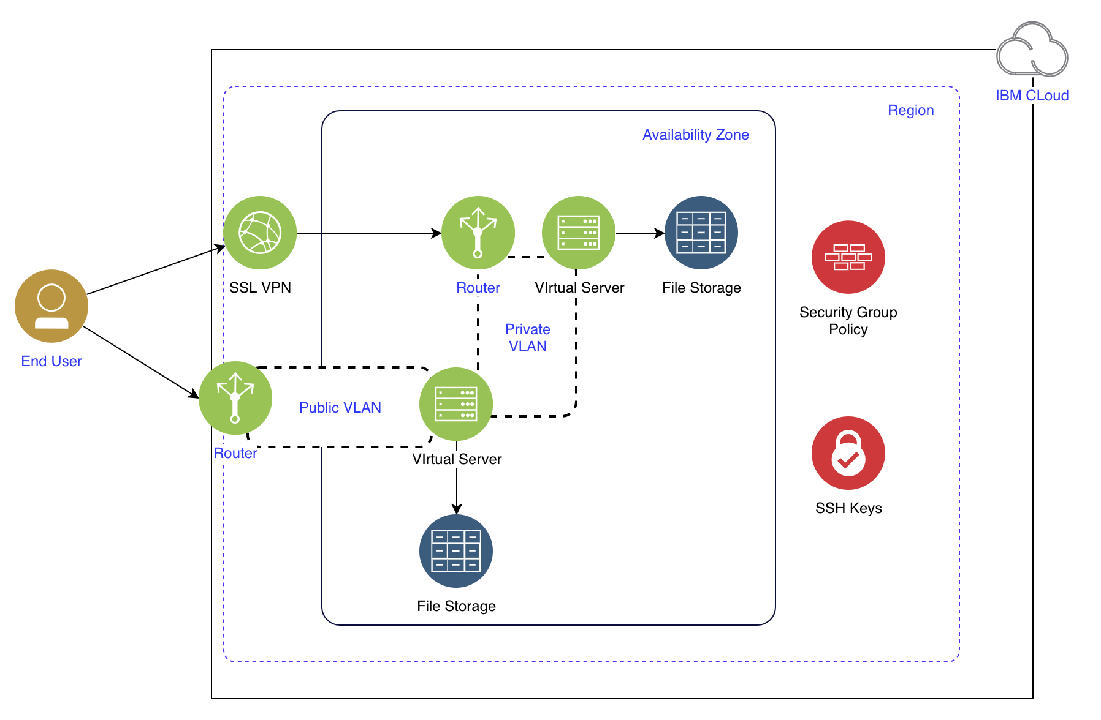

1. Review the architecture components:

|  |  |  |  |
| --- | --- | --- | --- |
| Component | Description | IBM Service | Provider Resource |
| [VSI](https://console.bluemix.net/docs/vsi/vsi_index.html#getting-started-tutorial) | Virtual server instance. One or more virtual servers deployed as multi-tenant instances into two availability zones. | Public VSI | ibm_compute_vm_instance |
| [File storage](https://console.bluemix.net/docs/infrastructure/FileStorage/index.html#getting-started-with-file-storage) | Two instances deployed as a common storage services for the virtual servers in that zone. | File Storage | ibm_store_file |
| [Security group](https://console.bluemix.net/docs/infrastructure/security-groups/sg_index.html#getting-started-with-security-groups) | Two groups. One group with policies for the virtual servers attached to the public network that allows limited messages on that network. A second group with policies for all virtual servers to limit communications between virtual servers on the private network. | Security Group | ibm_security_group  ibm_security_group_rule |
| [VLAN](https://console.bluemix.net/docs/infrastructure/vlans/getting-started.html#getting-started-with-vlans) | Virtual Local Area Network. Public allows communications to the public internet. Private limits communications between the virtual servers and resources on that network. | Public or Private VLAN | ibm_network_vlan |
| [Zone](https://www.ibm.com/blogs/bluemix/2018/06/expansion-availability-zones-global-regions/) | A physical area of a region that supports high availability. | Data Center | availability_zone |
| [Region](https://www.ibm.com/blogs/bluemix/2018/06/expansion-availability-zones-global-regions/) | A geographic region where an availability zone is located. | IBM Cloud Region | e.g. us_south, us-east |
| [SSH Key](https://console.bluemix.net/docs/infrastructure/ssh-keys/index.html#getting-started-tutorial) | SSH keys are used by SSH servers to identify a user or device through public-key cryptography. SSH-key-authorized users can add, edit, or delete SSH keys by using the IBM Cloud infrastructure customer portal. | Open VPN | ssh_key |
| [SSL VPN](https://console.bluemix.net/docs/infrastructure/iaas-vpn/about-vpn.html#ssl-vpn-subnet-limit) | A VPN to connect users to private VLANs | SSL VPN | sslvpn |

# 

# Step 6: Review Terraform files

This section will walk through the content in each of the Terraform configuration files. They use the IBM Could Provider for Terraform plug-in for determining what is written in each code block. You step through each of the files in the GitHub repository.

**Note:** Terraform doesn’t execute the code blocks in the file in order of appearance. Rather, it loads all to memory and determines the order to run based on explicit and implicit dependencies. For example, the virtual server blocks require the storage and SSH keys in place.

1. [main.tf](https://github.com/ibm-cloud-architecture/refarch-public-iaas-tutorial/blob/master/terraform/main.tf)

This file declares which Terraform providers are used in this configuration and provides any provider-specific information. The provider must be configured with the proper credentials before it can be used. In this case, the IBM Cloud infrastructure user name and API key. The API key is required to provision infrastructure resources.

1. [access_control.tf](https://github.com/ibm-cloud-architecture/refarch-public-iaas-tutorial/blob/master/terraform/access_control.tf)

This file creates a new SSH key from argument values and enters it into the IBM Cloud SSH key store. It can be reused as necessary. In this configuration, it will be used for all of the deployed virtual servers. It requires a public SSH key.

1. [storage.tf](https://github.com/ibm-cloud-architecture/refarch-public-iaas-tutorial/blob/master/terraform/storage.tf)

This file contains the information to create two NFS-based file storage instances in the same data center. It is then mounted to each of the virtual servers deployed.

1. [security.tf](https://github.com/ibm-cloud-architecture/refarch-public-iaas-tutorial/blob/master/terraform/security.tf)

This file contains the blocks to create two security groups and associated security policies. Each are used to limit communications of associated virtual servers on the public and private networks, respectively. The security group rules manage ingress and egress traffic to the virtual server instance.

1. [compute.tf](https://github.com/ibm-cloud-architecture/refarch-public-iaas-tutorial/blob/master/terraform/compute.tf)

This file contains the blocks to create two sets of virtual servers with the following properties:

* the total number of virtual servers is based on the **compute_count** variable
* the naming convention for the hostname produces unqiue names that are based on indexing from the count values
* the file storage and SSH key values refer to the ID of the storage an ID for each resource that is produced in the previous block
* An ID for each resource, which will be referenced in the following syntax: {**resource_type}.{resource_name.id}**. See the **file_storage_ids** in this block

1. [variables.tf](https://github.com/ibm-cloud-architecture/refarch-public-iaas-tutorial/blob/master/terraform/variables.tf)

This file contains the variables used by the .tf files. Several default values are left blank as they are respective to the user and the zone to provision. The remaining variables can be left as default for deployment unless changed otherwise. This pattern can be parameterized to be deployed to multiple data centers or regions, or to accommodate resources (i.e. VLANs).

Step 7: Update deployment variables

The Terraform configuration includes key variables that you provide values for. In this task, you add the values to those variables.

1. If you’ve never used the vi tool to edit files in Linux, review this [vi tutorial](https://developer.ibm.com/tutorials/l-lpic1-103-8/) to get familiar with the commands.
2. On a command line in your container, change the directory to the subdirectory that contains the Terraform scripts:   
   **cd refarch-public-iaas-tutorial/terraform**
3. Open the **variables.tf** file:  
   **vi variables.tf**

To edit, enter **I** and use the arrow keys to move the cursor to your variables.  
**Note**: Don’t exit the command line or vi until you are instructed to do so.

1. In the **variables.tf** file, find the **iaasapikey** variable. Paste your keys as the variable’s default value between the double quotation marks.



1. In the **variables.tf** file, find the **iaasusername** variable. Paste your IaaS username as the variable’s default value between the double quotation marks.



1. Add your public SSH key
2. Generate a public SSH key and have it accessible
3. In the **variables.tf** file, find the **ssh_key** variable. Paste he copied public key as the variable’s default value between the double quotation marks.



1. Add the Public and Private VLANs by finding the **publicvlanid** and **privatevlanid** variables and pasting the respective [VLAN IDs](https://console.bluemix.net/docs/infrastructure/vlans/about-vlans.html?cm_mmc=IBMBluemixGarageMethod-_-MethodSite-_-10-19-15::12-31-18-_-vlan-identification#vlan-identification).



1. Add the availability zone and region by finding the **availability_zone** and **region** variables and pasting the respective [availability zone and region](https://console.bluemix.net/docs/containers/cs_regions.html?cm_mmc=IBMBluemixGarageMethod-_-MethodSite-_-10-19-15::12-31-18-_-regions-and-zones#regions-and-zones) for this deployment.



1. Press “ESC”. Save your changes and close the **variables.tf** file using command **:wq** and click Enter.
2. Open the **variables.tf** file:  
   **vi variables.tf**
3. Verify that your changes are saved. If they are saved, press “ESC”, type the command **:q!** and press Enter to exit the vi tool without saving.

# Step 8: Deploy to IBM Cloud

1. Initialize the Terraform provider

The **terraform init** command is used to initialize a working directory that contains Terraform configuration files. This is the first command that should be run after writing a new Terraform configuration or cloning an existing one from version control. This step will move to the clone directory to start the provider.

In the terminal, enter the command **terraform init**  
**Note:** You should still be in the **Tutorial/terraform** directory.



You can now begin working with the Terraform configuration file. If you ever set or change modules or backend configuration for Terraform, rerun this command to reinitialize your working directory. If you forget, other commands will detect it and remind you to do so if necessary.

1. Review all the resources to be provisioned and identify any errors

In the terminal, enter the command **terraform plan**



1. If no errors are identified, provision the resources into IBM Cloud

In the terminal, enter the command **terraform apply**

1. When you are prompted, enter **yes** to complete the actions



Terraform begins to create your resources.

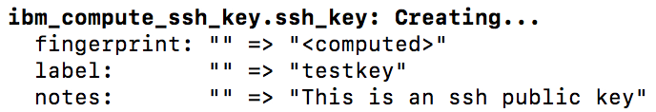

1. Confirm the details of your deployment, enter **terraform show** and click enter. Review the list of resources and details.
2. After you verify your deployment, clean up the environment and remove all the resources that were created during the apply activity

In the terminal, enter the command **terraform destroy**.